Write the python program for Missionaries Cannibal problem

## **AIM**

To implement a Python program that solves the **Missionaries and Cannibals problem** using **Breadth-First Search (BFS)** to safely transfer all missionaries and cannibals across the river without violating constraints.

## **ALGORITHM**

1. Represent each state as (M, C, B) where:
   1. M = missionaries on the left bank
   2. C = cannibals on the left bank
   3. B = boat position (1 = left, 0 = right)
2. Initialize the **start state** (3,3,1) and the **goal state** (0,0,0).
3. Use a queue to explore states in BFS order.
4. For each state (M,C,B):
   1. If it equals the goal, print the solution path and stop.
   2. Otherwise, generate all possible moves:  
       (1,0), (2,0), (0,1), (0,2), (1,1) representing the number of missionaries and cannibals to move.
   3. Compute new state based on the boat position.
   4. Check **validity**: number of missionaries >= number of cannibals on each side (unless missionaries = 0).
   5. Enqueue valid new states not already visited.
5. Repeat until the goal state is reached.

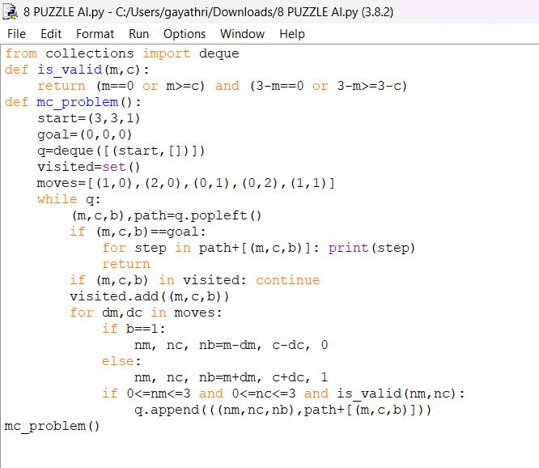

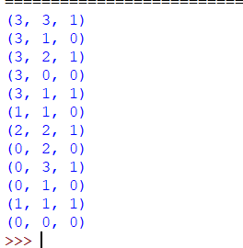

## **RESULT**

The program successfully solved the **Missionaries and Cannibals problem** using BFS.  
 It generated a sequence of safe moves transferring all 3 missionaries and 3 cannibals from the left bank to the right bank without any missionary being eaten.